***dt : 24/9/2022***

***Diagram:***

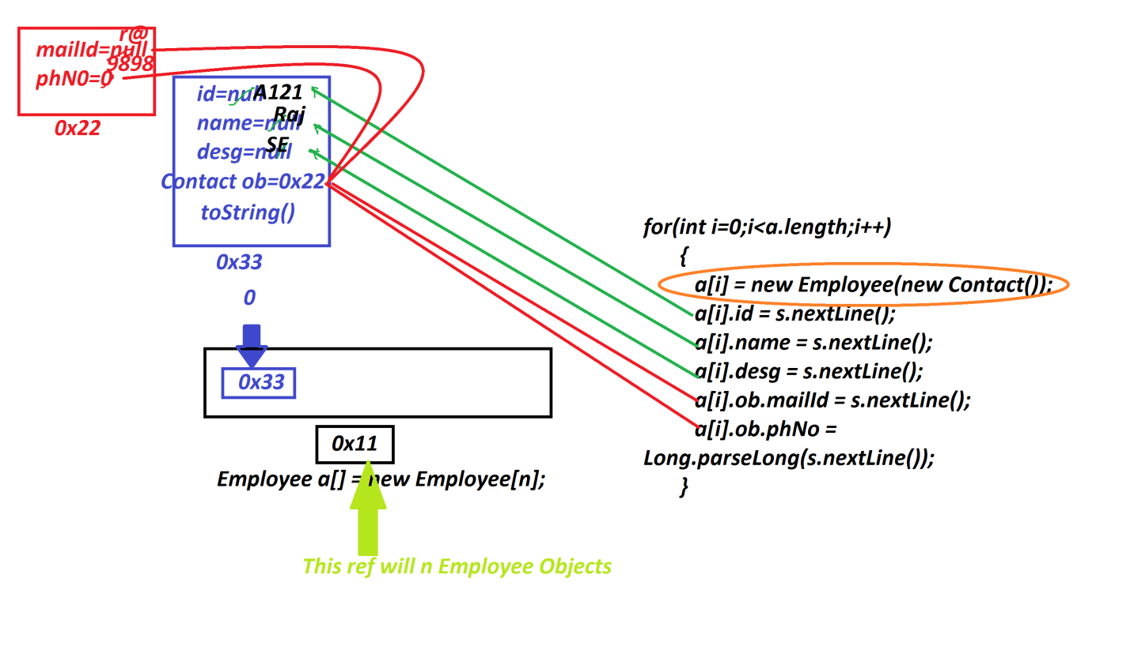

***========================================================***

***Ex:***

***wap to read and display Multiple Student details with result using***

***Arrays.***

***GenerateBranch.java***

***package test;***

***public class GenerateBranch {***

***public String generate(String code){***

***return switch(code) {***

***case "01":yield "CIVIL";***

***case "02":yield "EEE";***

***case "03":yield "MECH";***

***case "04":yield "ECE";***

***case "05":yield "CSE";***

***default:yield null;***

***};***

***}***

***}***

***CheckBranch.java***

***package test;***

***public class CheckBranch {***

***public boolean verify(String br)***

***{***

***return switch(br)***

***{***

***case "CSE" : yield true;***

***case "ECE" : yield true;***

***case "EEE" : yield true;***

***default : yield false;***

***};***

***}***

***}***

***StudentResult.java***

***package test;***

***public class StudentResult {***

***public String generate(float per,boolean p)***

***{***

***if(p)***

***{***

***return "Fail";***

***}***

***else if(per>=70 && per<=100)***

***{***

***return "Distinction";***

***}***

***else if(per>=60 && per<70)***

***{***

***return "FirstClass";***

***}***

***else if(per>=50 && per<60)***

***{***

***return "SecondClass";***

***}***

***else if(per>=35 && per<50)***

***{***

***return "ThirdClass";***

***}***

***else***

***{***

***return "fail";***

***}***

***}***

***}***

***Student.java***

***package test;***

***public class Student {***

***public String rollNo,name,branch,result;***

***public int totMarks;***

***public float per;***

***public String toString() {***

***return rollNo+"\t"+name+"\t"+branch+"\t"+totMarks+"\t"***

***+per+"\t"+result;***

***}***

***}***

***DemoStudent.java(MainClass)***

***package maccess;***

***import java.util.*;***

***import test.*;***

***public class DemoStudent {***

***public static void main(String[] args) {***

***Scanner s = new Scanner(System.in);***

***System.out.println("Enter the number of Students:");***

***int n = Integer.parseInt(s.nextLine());***

***Student a[] = new Student[n];***

***System.out.println("Enter "+n+" Student details:");***

***for(int i=0;i<a.length;i++)***

***{***

***a[i] = new Student();***

***System.out.println("****Deatils of Student-"+(i+1)+"***");***

***System.out.println("Enter the rollNo:");***

***a[i].rollNo = s.nextLine();***

***if(a[i].rollNo.length()==10)***

***{***

***GenerateBranch gb = new GenerateBranch();***

***String br = gb.generate(a[i].rollNo.substring(6,8));***

***if(br==null)***

***{***

***System.out.println("RollNo holding invalid branch code");***

***i--;***

***}//end of if***

***else***

***{***

***System.out.println("Enter the StuName:");***

***a[i].name=s.nextLine();***

***System.out.println("Enter the branch:");***

***a[i].branch=s.nextLine().toUpperCase();***

***CheckBranch cb = new CheckBranch();***

***boolean z = cb.verify(a[i].branch);***

***if(z)***

***{***

***if(a[i].branch.equals(br))***

***{***

***System.out.println("====Enter 6 Sub Marks====");***

***int j=1;//Initialization***

***int totM=0;***

***boolean p=false;***

***while(j<=6)***

***{***

***System.out.println("Enter Marks of Subject-"+j);***

***int sub = s.nextInt();***

***if(sub<0 || sub>100)***

***{***

***System.out.println("Invalid Marks...");***

***continue;***

***//skip the below lines from the Iteration***

***}***

***if(sub>=0 && sub<=34)//Fail Condition***

***{***

***p=true;***

***}***

***totM = totM+sub;***

***j++;***

***}//end of while***

***a[i].totMarks=totM;***

***a[i].per=(float)a[i].totMarks/6;***

***StudentResult sr = new StudentResult();***

***a[i].result = sr.generate(a[i].per, p);***

***}//end of***

***else***

***{***

***System.out.println("RollNo not matched with branch");***

***i--;***

***}***

***}//end of if***

***else***

***{***

***System.out.println("Invalid branch...");***

***i--;***

***}***

***}***

***}//end of if***

***else***

***{***

***System.out.println("Invalid rollNo...");***

***i--;;***

***}***

***}//end of loop***

***System.out.println("====StudentDetails with result====");***

***for(Student k: a)***

***{***

***System.out.println(k.toString());***

***}//end of loop***

***s.close();***

***}***

***}***

***o/p:***

***Enter the number of Students:***

***2***

***Enter 2 Student details:***

***\*\*\*\*Deatils of Student-1\*\*\****

***Enter the rollNo:***

***1234560590***

***Enter the StuName:***

***Raj***

***Enter the branch:***

***cse***

***====Enter 6 Sub Marks====***

***Enter Marks of Subject-1***

***90***

***Enter Marks of Subject-2***

***98***

***Enter Marks of Subject-3***

***98***

***Enter Marks of Subject-4***

***97***

***Enter Marks of Subject-5***

***96***

***Enter Marks of Subject-6***

***95***

***\*\*\*\*Deatils of Student-2\*\*\****

***Enter the rollNo:***

***Invalid rollNo...***

***\*\*\*\*Deatils of Student-2\*\*\****

***Enter the rollNo:***

***1234560490***

***Enter the StuName:***

***Ram***

***Enter the branch:***

***ECe***

***====Enter 6 Sub Marks====***

***Enter Marks of Subject-1***

***76***

***Enter Marks of Subject-2***

***78***

***Enter Marks of Subject-3***

***74***

***Enter Marks of Subject-4***

***54***

***Enter Marks of Subject-5***

***56***

***Enter Marks of Subject-6***

***55***

***====StudentDetails with result====***

***1234560590 Raj CSE 574 95.666664 Distinction***

***1234560490 Ram ECE 393 65.5 FirstClass***

***================================================================***

***Assignment:***

***Update above Student application as follows:***

***=>Student holding references of Address and Contact.***

***Diagram:***



